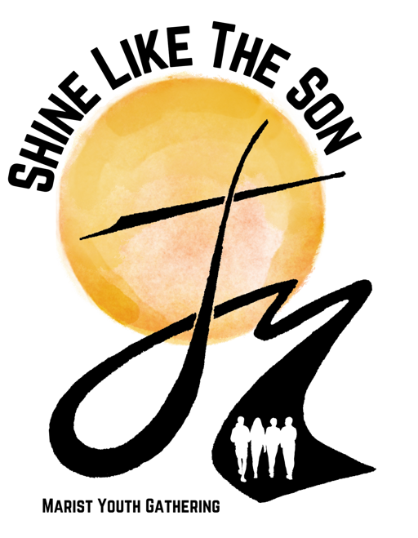**Packing List for the Marist Youth Gathering**

**Marist College, Poughkeepsie, NY**

**Clothing:**

* Pack comfortable appropriate cloths
  + T-shirts/shorts/jeans enough for 4 days at Marist College
  + You will receive a t-shirt to wear Monday
  + Sandals or flip flops are fine for most events.
* Athletic cloths for the Champagnat Games
  + Sneakers/Tennis Shoes must be worn.
* Some people bring a nicer outfit for Mass Sunday evening
  + This is not required but you will have time to shower and change
  + Keep it classy but casual

**Toiletries:**

* Soap
* Shampoo
* Toothpaste
* Toothbrush
* Deodorant

**Bedding:**

***We are very limited in extra so please remember!***

* Twin Extra Long Bed Sheets or sleeping bag
* Pillow and Pillow Case
* Towel (We have no extra towels!)
* Blanket

**Trade – ables:**

* Items with your school name/logo are fun to trade
  + T-Shirts
  + Sweatshirts
  + Lanyards
  + Magnets
  + Stickers
  + Etc

**Extra Money:**

* While at Marist College the Marist Young Adults will be selling T-shirts Sleeve for $20 each. As well as St. Marcellin Champagnat Medals for $5.
* Your meals and snacks will be provided from Dinner on Friday through breakfast on Sunday. During your stay at Marist College, you will not need spending money. There are some vending machines throughout the dormitories if you would like to purchase a drink or snack.

Follow **@MaristYouthUSA** on Instagram and Twitter

Like Marist Youth USA on Facebook

www.MaristYouth.com