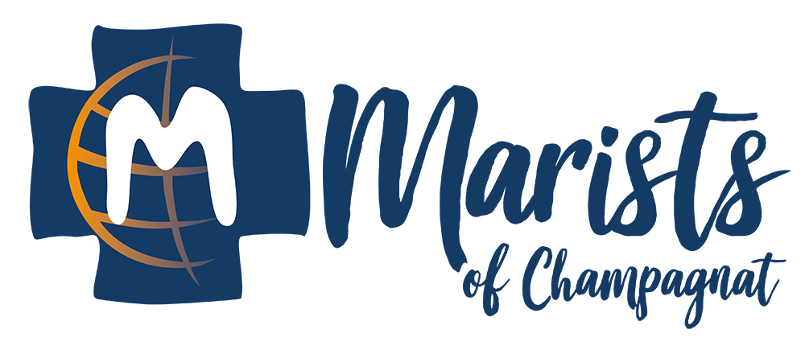

**Marist Community of Welcome**

**PLAN FOR COMMUNITY LIFE: 2023**

Leader: “The Lord God said,

All: ‘It is not good for man to be alone.’” (Genesis 2:18a)

Leader: Glory to the Father, and to the Son, and to the Holy Spirit,

All: As it was in the beginning, is now, and will be forever. Amen. Alleluia

Here in this place new light is streaming  
Now is the darkness vanished away  
See in this space our fears

and our dreamings  
Brought here to you in the light of this day  
Gather us in, the lost and forsaken  
Gather us in, the blind and the lame  
Call to us now and we shall awaken  
We shall arise at the sound of our name

We are the young, our lives are a mystery  
We are the old who yearn for your face  
We have been sung throughout all of history  
Called to be light to the whole human race  
Gather us in, the rich and the haughty  
Gather us in, the proud and the strong  
Give us a heart so meek and so lowly  
Give us the courage to enter the song

Not in the dark of buildings confining  
Not in some heaven light years away  
But here in this place

the new light is shining  
Now is the kingdom, now is the day  
Gather us in and hold us forever  
Gather us in and make us your own  
Gather us in, all peoples together  
Fire of love in our flesh and our bones  
Fire of love in our flesh and our bones

**Acts 2: Life among the Believers**

**43**Many miracles and wonders were being done through the apostles, and everyone was filled with awe. **44**All the believers continued together in close fellowship and shared their belongings with one another. **45**They would sell their property and possessions, and distribute the money among all, according to what each one needed. **46**Day after day they met as a group in the Temple, and they had their meals together in their homes, eating with glad and humble hearts, **47**praising God, and enjoying the good will of all the people. And every day the Lord added to their group those who were being saved.

*Let us build a house where love can dwell and all can safely live,  
a place where saints and children tell how hearts learn to forgive.  
Built of hopes and dreams and visions, rock of faith and vault of grace;  
here the love of Christ shall end divisions.  
All are welcome, all are welcome, all are welcome in this place.*

**Founding of the Little Brothers of Mary in 1817**

As part of his ministry, Father Champagnat often traveled the rocky mountain paths to administer the sacraments to the sick and the dying. It was on one of these trips to a young boy that he decided to found a congregation of teaching brothers. He found the dying boy ignorant of the most elementary truths of religion. For two hours Father Champagnat prepared him for death. He left the boy with the consolation that a soul had been saved. This incident affected him so deeply that he decided to confide to a young parishioner, Jean Marie Granjon, his desire to organize a teaching brotherhood that would educate young men in the fundamentals of the "Faith."

Six months after his arrival at LaValla, Father Champagnat founded the Marist Brothers. Two young men, Jean Marie Granjon and Jean Baptiste Audras, were received as its first members on January 2, 1817. They were lodged near the rectory in a house which had been rented by Father Champagnat for their novitiate. He visited them daily to teach them the principles of religious and community life. He drew up a temporary set of rules to mold these two young country boys into cultured religious gentlemen. The following March in order to distinguish them from the laity he gave them names in religion and a distinctive attire in blue.

*Let us build a house where prophets speak, and words are strong and true,  
where all God’s children dare to seek to dream God’s reign anew.  
Here the cross shall stand as witness and as symbol of God’s grace;  
here as one we claim the faith of Jesus.  
All are welcome, all are welcome, all are welcome in this place.*

**Founding of the Marist Community of Welcome in Austin, Texas**

On November 5, 2018 the Marist Brothers of the Province of the United States of America received the Canonical Consent of Bishop Joe Vasquez, Ordinary of the Diocese of Austin to open a new initiative, the Marist Community of Welcome. In the letter requesting his “consent” (Canon 609) it was shared that “The Marist Brothers envision this community as a home to welcome young adults to share in the prayer, service and fraternal life of the brothers.”  
On May 1, 2019 a community of 5 young adults and 2 Marist Brothers began community life on Greenway Street in Austin, Texas.

*Let us build a house where hands will reach beyond the wood and stone  
to heal and strengthen, serve and teach, and live the Word they’ve known.  
Here the outcast and the stranger bear the image of God’s face;  
let us bring an end to fear and danger.  
All are welcome, all are welcome, all are welcome in this place*

**Vision Statement Marist Community of Welcome**

We are a community of young adults and Marist Brothers

united in faith by the love of Christ and guided by the Marist Spirit.

Our brotherhood is fostered by our commitment to:

hospitality, group prayer, shared meals and genuine concern for each person..  
  
*Let us build a house where all are named, their songs and visions heard  
and loved and treasured, taught and claimed as words within the Word.  
Built of tears and cries and laughter, prayers of faith and songs of grace,  
let this house proclaim from floor to rafter.  
All are welcome, all are welcome, all are welcome in this place.*

**Community Reflection:**

**What are my hopes, fears and expectations as we begin our Community life together?**

**Commitment of Community Members**

Since our beginning in 2019 we have found that a certain spirit has developed among us and a variety of practical aspects of our living together have been agreed upon by our community members**.**

The spirit of our community has been fostered by certain attitudes which include:

Our desire to live a Christian community life-style and a willingness to make our presence and participation in the community a priority;

* Our willingness to grow deeper in both our Christian faith and knowledge of the Marist charism and then sharing this with each other;
* We strive to have open and honest communication and respect with other community members;
* As a “Community of Welcome” we welcome those who visit us.

The practical details of living-well together are determined with each new community as they need to be adjusted to the reality of our community members. These details have included:

1. Our presence and participation with the community:
2. Our weekly “Marist Monday” held on Monday evenings. Which is a time for: prayer, socializing, dinner, a community conversation and sometimes another activity together
3. We have a weekly “check-in” to share where we are personally and how we see our community life together.
4. We pray together Monday and Wednesday evenings and Tuesday thru Thursday mornings
5. Throughout the week we join together for an evening meal and prayer as schedules permit. If possible we join the community on Wednesday evening for prayer and dinner.
6. We recognize that sometimes one of us may be home and won’t be joining the community for prayer and dinner.
7. We enjoy being present to each other in more informal moments – “hanging out” with the others
8. We regularly cook dinner for each other (usually once a week, or every-other-week);
9. We join in shopping for our food, while maintaining a responsible use of our community funds;
10. Since this is both our home and a place of welcoming guests, we each take personal responsibility to keep the public rooms clean and neat by cleaning up after ourselves, In addition, we help maintain the house and property through an “employment” which is our responsibility to help clean/maintain a different section of the houses and property;
11. All community members contribute to the costs of room, board and utilities (which includes Wi-Fi);
12. We live in a rented house and so we are required to follow all the stipulations of the lease;
13. Our community is sponsored and supported by the Marist Brothers, a religious community in the Catholic Church. In keeping with our Christian foundation, while at home, we follow all church and civil laws.

**Appetizer 1) Group Meeting; 2) Groups Sharing; 3) Sondage: Plan for Community Life**

**Dinner**

**Dessert with Personal Check-in**